**HR Analysis in Employee Performance**

**Poster Presentation**

**(Shajidul Karim Saadi)**

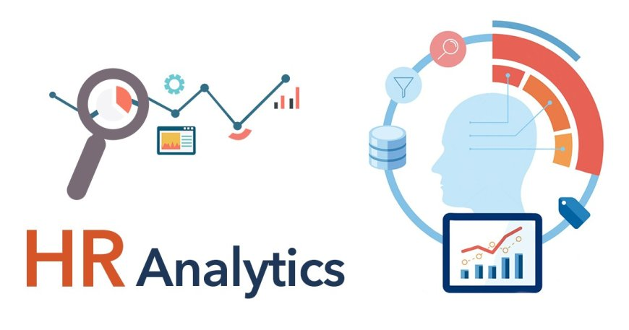

**Background: This project’s background is to previous few years employee performance data analysis. Employee were motivated in different sector, department, people etc.**



**Purpose: The first and for more important purpose is to identify employee performance based on different kinds of data analysis.**

**Results**



**Performance Evaluation:**

* The overall Organization’s performance day by day.
* The level of performance depends on different educational background level.
* The training session also impact on the performance.
* Sourcing recruitment channel employee win more awards then others.
* Some set of factors depends on Organizational Performance.

